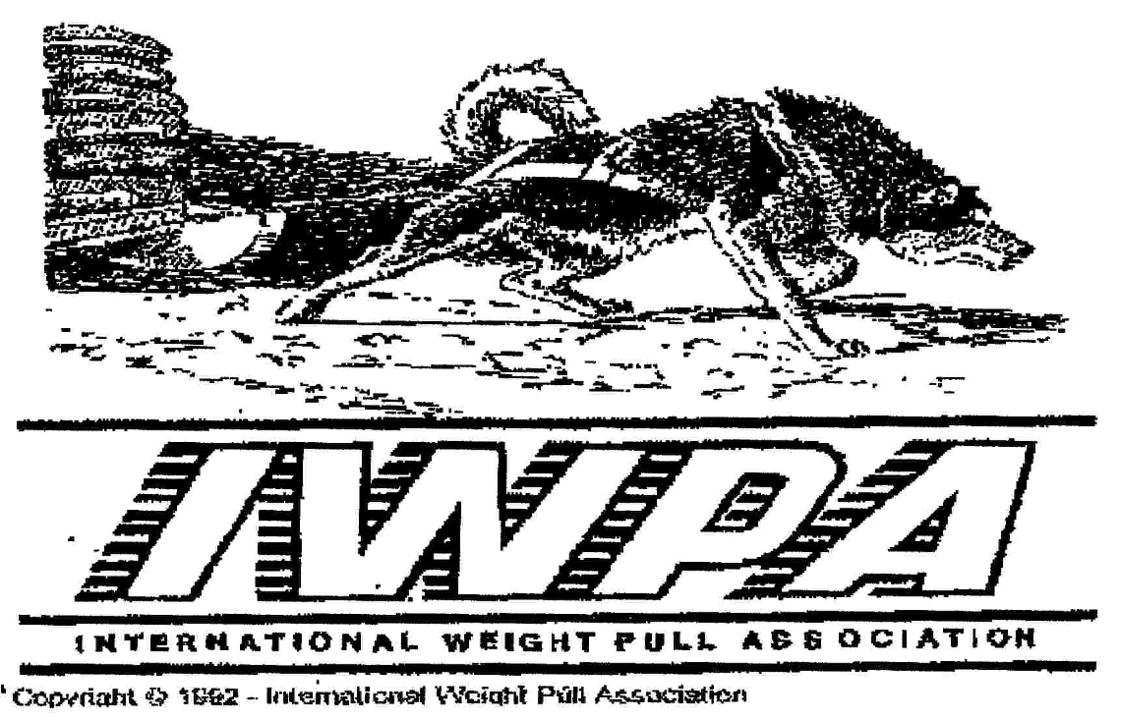

Judge Renewal

Name_______________________________________
Address_____________________________________
City, State (Province) __________________________
Zip (Postal Code) _____________Region__________
Telephone___________________________________
E-mail______________________________________
Judge renewal before September 1, 2015 $10.00

After September 1, 2015 $15.00 Make checks payable to the IWPA

Mail to:
IWPA Judges Chair
Bob Sencenbaugh
PO Box 637
Erie, CO 80516
(303)744-8824
E-Mail: starcheywsx@msn.com

Note: Renewing Judges must sign and return this form (with the proper fee) stating that you have read and understand the following changes in the IWPA Standing rules and Rule booklet that have been placed in effect at the board meeting on June 6, 2015. This also includes the Judges Code of Conduct that was adopted by the board in 2002.

International Weight Pull Association
Judge Code of Conduct (Ethics and Authority)
1. You must both possess and project an unwavering air of integrity and ethical behavior that protects the reputation of IWPA pull events as fair and well-judged. With common sense, judges can easily avoid situations, which might raise ethical questions. A judge should avoid impropriety and the appearance of impropriety in all activities.
2. Judges are presumed to be honest, competent and dedicated. Nevertheless, it is all too easy to find yourself in uncomfortable or even inappropriate situations. Guidelines cannot cover every situation, but they can help you avoid improprieties or perceived improprieties. A judge should perform the duties impartially and diligently. ("A judge shall disqualify himself or herself in a proceeding in which the judge's impartiality might reasonably be questioned, including but not limited to instances in which the judge has a personal bias or prejudice concerning a party...")

3. You Are in Charge: As the Chief Judge, you have full authority over all persons in the event. With this authority comes the responsibility to be thoughtful and considerate. Be as systematic in your procedure from dog to dog and weight class to weight class as conditions permit.
4. You should avoid theatrical movements or making inappropriate comments to competitors. Be polite, but generally limit your conversation with competitors to instructions that are in accordance with the IWPA rules.
5. The Judge may use whatever reasonable procedures he/she deems necessary to evaluate each dog's performance in an effective and efficient manner. The same procedures will be used to Judge each dog in a class. By entering any weight pull, the owner and handler of any dog agree to accept the decision of the Judge as final. The decision of a Judge is the responsibility of the Judge and not that of the IWPA.
6. IWPA events are intended to be family-oriented recreation for dog lovers and their dogs. Accordingly, IWPA expects the highest standard of conduct at all events.

Remember you must renew your membership to renew you judges credentials

Rule Changes for 2015-2016

There are no rule changes for the 2015 – 2016 season; however we have added a new class. The class breakdowns are as follows: 0-10, 11-25, 26-40,41-60, 61-80, 81-100, 101-125, 126-150, Unlimited

Questions for this year’s renewal:
You must get both questions correct, if you do not a second set of questions will be sent.
- If a dog is currently 10 months old but will turn 1 year’s old during the season they will be permitted to enter the competition. T F

- If you are participating in a pull, and you see or hear about a violation of the rules you are not obligated to become involved unless you are judging the class or are the Chief Judge. T F

_____________________________________
Signature
Official Use Only
Postmark Date:
Date Received:

